# Teaser Video 1: **DOP- January 04, 2023**

Copy: You know what they say, "New Year, New Me." 😜

Get excited. A REVOLUTION IS COMING! 👀

<https://youtu.be/acE-PmnJttQ>

#Networking #IndustrialNetworking #ManagedEthernetSwitches #EthernetSolutions #Industry40 #RedLionControls #TheIndustrialDataCompany #IIoT #IntuitiveNetworking

Post preview:

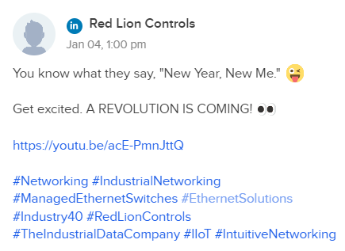

# Teaser Graphic 1: **DOP- January 05, 2023**

Copy: Setting up a new switch configuration can be confusing. Our new N-Tron Series switch makes it easier than ever. Build your network with Red Lion.

#Networking #IndustrialNetworking #ManagedEthernetSwitches #EthernetSolutions #Industry40 #RedLionControls #TheIndustrialDataCompany #IIoT #IntuitiveNetworking

Post preview:



# Teaser Graphic 2: **DOP January 09, 2023**

Copy: Introducing our next innovation in switches. With a modern graphical interface, configuration wizard, layered network security, and gigabit speed, the 𝗡𝗧𝟱𝟬𝟬𝟬 offers reliability, performance, and ease of use - all with seamless integration. Build your network with Red Lion.

#Networking #IndustrialNetworking #ManagedEthernetSwitches #EthernetSolutions #Industry40 #RedLionControls #TheIndustrialDataCompany #IIoT #IntuitiveNetworking

Post preview:

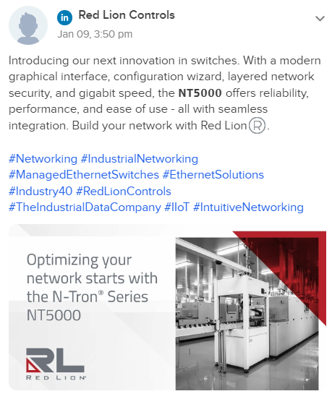

# Teaser Video 2: **DOP- January 10, 2023**

Copy: We can't hold our excitement. 😎😎

Coming soon: 𝗥𝗘𝗗 𝗟𝗜𝗢𝗡'𝗦 𝗡𝗘𝗫𝗧 𝗜𝗡𝗡𝗢𝗩𝗔𝗧𝗜𝗢𝗡 𝗜𝗡 𝗦𝗪𝗜𝗧𝗖𝗛𝗘𝗦!

Stay tuned...

<https://youtu.be/COI-wnkXju4>

#Networking #IndustrialNetworking #ManagedEthernetSwitches #EthernetSolutions #Industry40 #RedLionControls #TheIndustrialDataCompany #IIoT #IntuitiveNetworking

Post preview:

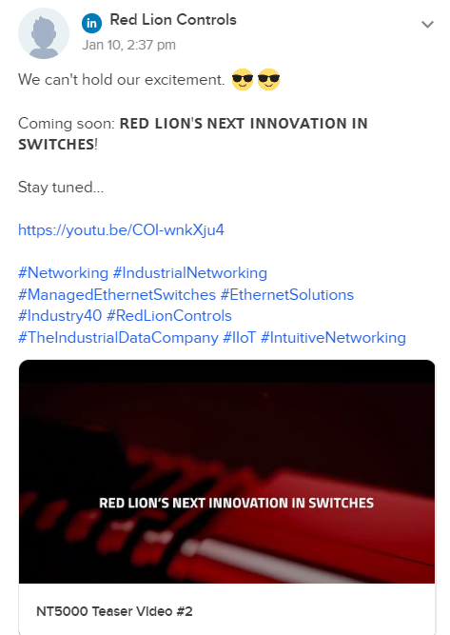

# Teaser Graphic 3: **DOP- January 12, 2023**

Copy: Imagine a single point where administrators can quickly see active ports, traffic and errors. The new 𝗡-𝗧𝗿𝗼𝗻 𝗦𝗲𝗿𝗶𝗲𝘀 switches make it possible.

#Networking #IndustrialNetworking #ManagedEthernetSwitches #EthernetSolutions #Industry40 #RedLionControls #TheIndustrialDataCompany #IIoT #IntuitiveNetworking

Post preview:

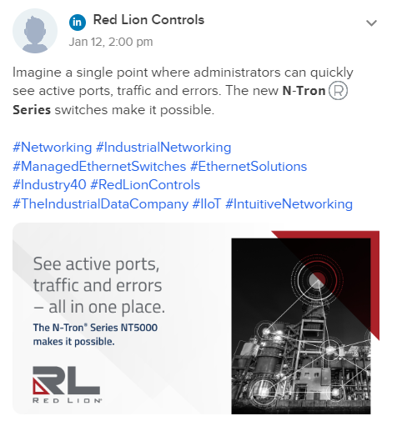

# Teaser Graphic 4: **DOP- January 16, 2023**

Copy: Compact, durably built, innovative connectivity, exceptional intuitive graphical interface. Expect more from your network’s switches. Our new 𝗡-𝗧𝗿𝗼𝗻 𝗦𝗲𝗿𝗶𝗲𝘀 𝗡𝗧𝟱𝟬𝟬𝟬 gigabit managed Layer 2 switches are designed for network reliability, both today and tomorrow.

#Networking #IndustrialNetworking #ManagedEthernetSwitches #EthernetSolutions #Industry40 #TheIndustrialDataCompany #RedLionControls #IIoT #NetworkVisualization

Post preview:

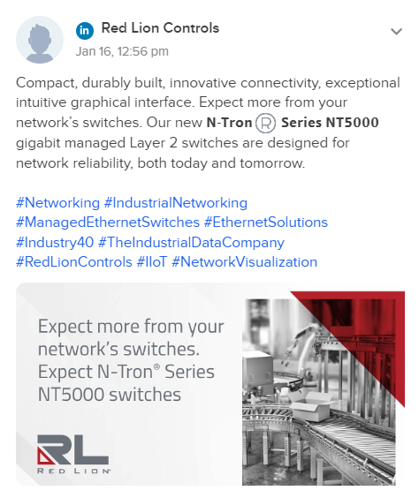

# Teaser Graphic 5: **DOP- January 17, 2023**

Copy: Choose industrial Ethernet-managed switches that are compact, intuitive, feature-rich and offer multiple port configurations. Get the gigabit performance you need in a switch that is compact, easy to use and reliable. 𝗧𝗵𝗲 𝗳𝘂𝘁𝘂𝗿𝗲 𝗶𝘀 𝗻𝗼𝘄 𝗼𝗻𝗹𝘆 𝗳𝗿𝗼𝗺 𝗥𝗲𝗱 𝗟𝗶𝗼𝗻.

#Networking #IndustrialNetworking #ManagedEthernetSwitches #EthernetSolutions #TheIndustrialDataCompany #RedLionControls #IIoT

Post preview:

